MILITARY COLLEGE OF SIGNALS
FINAL-SEMESTER-EXAM:BESE 14(A&B)
NUMERICAL ANALYSIS

Instructor: Gp Capt Umar Farooq (Retd) Max Time: 2 1/2 Hours
Max Marks: 50

ATTEMPT ALL QUESTIONS. SHOW THE DETAILS OF YOUR WORK

Q1: Find the second Taylor polynomial 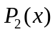 for the function 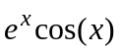 about 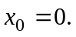Find an upper bound for the error at 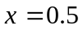 using error formula.
(4+3)
Q2: The arc length of a curve 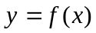 over the interval 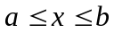 is given by the formula 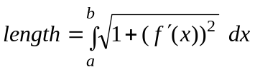. Approximate the arc length of 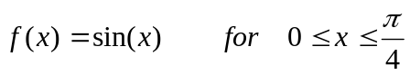 using Simpson’s rule with M=5. (7)
Q3: Find the interval where the negative root of 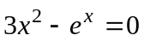 is lying, then find the root using Newton-Raphson method correct up to six significant figures. Select appropriate initial value to avoid extra # of iterations. (7)

Q4: Find the natural Cubic Spline that passes through (0, 0.0), (1, 0.5), (2, 2.0) and
(3, 1.5) with the free boundary conditions 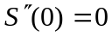 and 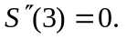 (8)

Q5: When the population 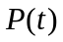 is bounded by the limiting value, it follows a
Logistic curve and has the form 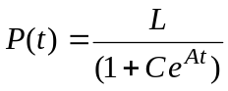 . Use the following data for the U S population and find the logistic curve:
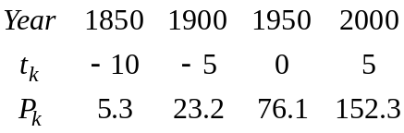 Assume that 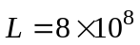
Estimate the population in the year 2050 (7)

Q6: The circle 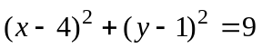cuts the x-axis at two point .Find both the x-intercepts to an accuracy of 3 digits using bisection method. (7)

Q7: Find a zero of 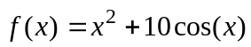 by using the fixed point iteration for an appropriate iteration function  accurate to within 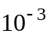 (7)

